 |   e-Business Intelligent Suite for Customs and Trade
E-Biscus Reference Documentation
input.doc
e-Biscus Manifest XML File Interface Specification
Cover Page / Approvals
Approvals:
PROVIDER  (Name, date & signature) | CUSTOMER  (Name, date & signature)
Distribution:

Firm/Agency | Names | Functions
Bull SA | JFB | Business Applications
Bull SA | FMO | Software Products
Bull SA | PBR | Customs Business Unit

E-Biscus Reference Documentation
e-Biscus Manifest XML File Interface Specification
Creation Page/ Updates

N° Version | Date application | Nature | Pages | Motivation
1.0  1.4 | 01/03/2002  09/10/2002 | Cargo manifest interface  Addition of deconsolidation interface | All  All | LMI: Creation  LMI: Additions
1.41 | 11/11/2002 | Added screenshots | Some | PBR: Additions
1.5 | 06/03/2003 | Added CPA interfaces (registering and control reports) | 18-End | LXY: Additions

E-Biscus Reference Documentation
e-Biscus Manifest XML File Interface Specification
Summary Page
1. Cargo Manifest 4
1.1 DTD specification 4
1.2 Description of the fields 5
1.2.1 Format 5
1.2.2 Correspondence with air manifest screen 6
1.2.3 Correspondence with sea manifest screens 7
1.3 XML Example 8
2. Deconsolidation 13
2.1 DTD specification 13
2.2 Description of the fields 14
2.2.1 Format 14
2.2.2 Correspondence with air deconsolidation screen 15
2.2.3 Correspondence with sea deconsolidation screen 16
2.3 XML Example 16
3. Entry into Customs Area on Import 18
3.1 DTD specification 18
3.2 Description of the fields 18
3.2.1 Format 18
3.2.2 Correspondence with Check report screen (Entry into Customs Area) 19
4. End of Deconsolidation 20
4.1 DTD specification 20
4.2 Description of the fields 20
4.2.1 Format 20
4.2.2 Correspondence with Check report screen (End of Deconsolidation) 21
5. Register a previously entered Cargo Manifest on import (SMSD) 22
5.1 DTD specification 22
5.2 Description of the fields 22
5.2.1 Format 22
5.2.2 Correspondence with create/modify cargo manifest screen 22
6. Register a previously entered Deconsolidation Manifest on import (HMSD) 23
6.1 DTD specification 23
6.2 Description of the fields 23
6.2.1 Format 23
6.2.2 Correspondence with Create/Modify House Manifest Screen 23

Cargo Manifest

DTD specification
<?xml version="1.0" encoding="UTF-8"?>
<!-- Copyright (c) 2002 Bull S.A. All rights reserved. -->
<!ELEMENT manifest (manisd+)>
<!ELEMENT manisd (type, customsoffice, arrivedate, transportmeansinfo, originalnation, meansnation, nillcargo, captain?, rotationnumber?, remark?, onboard, onboardcomment?, shipagent?, td*)>
<!ELEMENT type (#PCDATA)>
<!ELEMENT customsoffice (#PCDATA)>
<!ELEMENT arrivedate (#PCDATA)>
<!ELEMENT transportmeansinfo (#PCDATA)>
<!ELEMENT originalnation (#PCDATA)>
<!ELEMENT meansnation (#PCDATA)>
<!ELEMENT nillcargo (#PCDATA)>
<!ELEMENT captain (#PCDATA)>
<!ELEMENT rotationnumber (#PCDATA)>
<!ELEMENT remark (#PCDATA)>
<!ELEMENT onboard (#PCDATA)>
<!ELEMENT onboardcomment (#PCDATA)>
<!ELEMENT shipagent (#PCDATA)>
<!ELEMENT td (prefix, tdbillno, consolidated, importer, consignee?, notify?, tstatus?, tdremark?, tranship, restrictcode?, prepaid, lp+, container*)>
<!ELEMENT prefix (#PCDATA)>
<!ELEMENT tdbillno (#PCDATA)>
<!ELEMENT consolidated (#PCDATA)>
<!ELEMENT importer (#PCDATA)>
<!ELEMENT consignee (#PCDATA)>
<!ELEMENT notify (#PCDATA)>
<!ELEMENT tstatus (#PCDATA)>
<!ELEMENT tdremark (#PCDATA)>
<!ELEMENT tranship (#PCDATA)>
<!ELEMENT restrictcode (#PCDATA)>
<!ELEMENT prepaid (#PCDATA)>
<!ELEMENT lp (packagecode, totalquantity, grossweight, description, packagemark?, lpremark?)>
<!ELEMENT packagecode (#PCDATA)>
<!ELEMENT totalquantity (#PCDATA)>
<!ELEMENT grossweight (#PCDATA)>
<!ELEMENT packagemark (#PCDATA)>
<!ELEMENT description (#PCDATA)>
<!ELEMENT lpremark (#PCDATA)>
<!ELEMENT container (ctnumber, cttype, ctsize, ctsealnumber, ctremark?)>
<!ELEMENT ctnumber (#PCDATA)>
<!ELEMENT cttype (#PCDATA)>
<!ELEMENT ctsize (#PCDATA)>
<!ELEMENT ctsealnumber (#PCDATA)>
<!ELEMENT ctremark (#PCDATA)>

Description of the fields

Format
Field | Format | M/O | Occurs | Description
Summary declarations
type | A1 | M | Min: 1 Max: No | Manifest type Air:A;Sea:S
customsoffice | AN3 | M | Min: 1 Max: No | Customs office where the SD is issued.
arrivedate | Date | M | Min: 1 Max: No | Date of arrival of the means of transportation.
originalnation | A2 | M | Min: 1 Max: No | Country the vessel is coming from.
meansnation | A2 | M | Min: 1 Max: No | Country of the vessel
transportmeansinfo | Air: AN8  Oth: an40 | M | Min: 1 Max: No | Air: Flight number.  Sea: Name of the ship.
remark | an255 | O | Min: 1 Max: No | Informational message to Customs.  Free text
nillcargo | B | M | Min: 1 Max: No | Must be set to True if means of transportation has no cargo. Mandatory for sea and air, not used otherwise.
rotationnumber | AN10 | O | Min: 1 Max: No | Given by CPA.  Mandatory for sea, not used otherwise
captain | an40 | O | Min: 1 Max: No | Optional for sea, not used otherwise.
onboard | B | M | Min: 1 Max: No | Mandatory for sea and air, not used otherwise.
onboardcomment | an255 | O | Min: 1 Max: No | Mandatory if “cargo remaining on board” is set to “True”, disabled otherwise.
shipagent | AN8 | O | Min: 1 Max: No | Authorisation number.  Mandatory for sea, not used for other.
Transport documents
prefix | Air: N3  Sea: AN6 | M | Min:1/SD Max: No |  | Air: Airline code  Sea: Port of issuance
tdbillno | Air: N8 Sea: an18 | M |  |  | Air: IATA code (N7 + check digit)  Sea : Bill of lading
consolidated | B | M |  |  | If the TD is consolidated
importer | N8 | M |  |  | TR# of carrier, Checked against trader registry.
consignee | an40 | O |  |  | Consignee name
notify | an40 | O |  |  | Person to notify on arrival. Free text.
tstatus | AN4 | O |  |  | Status of goods
tdremark | an255 | O |  |  | Free text (informational)
tranship | B | M |  |  | If the cargo is not to leave the free port area.  Mandatory for sea, disabled otherwise
restrictcode | B | O |  |  | Special import restrictions code
prepaid | B | M |  |  | If freight has been paid
Lines of packages
packagecode | A2 | M | Min: 1/TD Max: No |  | Type of package
totalquantity | N8 | M |  |  | The number of packages of this type.
grossweight | N11,3 | M |  |  | Gross weight in kilograms.
packagemark | an80 | O |  |  | Marks of the packages
description | an255 | M |  |  | Summary description of the packages contents. Free text.
lpremark | an255 | O |  |  | Free text (informational)
Containers
ctnumber | AN11 | M | Min: 0 Max: No |  | Container number
cttype | A1 | M |  |  | Contain type. The valid values are  F:FCL  L: LCL
ctsize | N2 | M |  |  | Contain size: 20, 40, etc.
ctsealnumber | An16 | M |  |  | Container seal number
ctremark | an255 | O |  |  | Container remark

Correspondence with air manifest screen

Correspondence with sea manifest screens

XML Example
Here follows an example of XML cargo manifest based on this DTD.
The http address of the DTD shall be set to the address of the Customs server.

<?xml version="1.0" encoding="UTF-8"?>
<!-- Copyright (c) 2002 Bull S.A. All rights reserved. -->
<!DOCTYPE manifest SYSTEM "http://www.ebiscus.com/manifest/fileload/manifest.dtd">
<manifest>
<manisd>
<type>A</type>
<customsoffice>130</customsoffice>
<arrivedate>30/05/2002</arrivedate>
<transportmeansinfo>abc dfe</transportmeansinfo>
<originalnation>CN</originalnation>
<meansnation>CY</meansnation>
<nillcargo>N</nillcargo>
<captain>Wang yue lin</captain>
<rotationnumber></rotationnumber>
<onboard>N</onboard>
<shipagent>83921233</shipagent>
<td>
<prefix>abcdef</prefix>
<tdbillno>11111111</tdbillno>
<consolidated>N</consolidated>
<importer>12345678</importer>
<notify>fnkerf</notify>
<tstatus>hgjk</tstatus>
<tdremark>bfrhefrbhrefhf</tdremark>
<tranship>N</tranship>
<prepaid>Y</prepaid>
<lp>
<packagecode>PL</packagecode>
<totalquantity>10</totalquantity>
<grossweight>20.01</grossweight>
<description>DEscrpvnfref</description>
<packagemark>492fref</packagemark>
<lpremark>fmfref</lpremark>
</lp>
</td>
<td>
<prefix>abcdef</prefix>
<tdbillno>121212121212</tdbillno>
<consolidated>N</consolidated>
<importer>12345678</importer>
<notify>fnkerf</notify>
<tstatus>hgjk</tstatus>
<tdremark>bfrhefrbhrefefhbrhebf</tdremark>
<tranship>N</tranship>
<prepaid>Y</prepaid>
<lp>
<packagecode>PL</packagecode>
<totalquantity>11</totalquantity>
<grossweight>20.01</grossweight>
<description>DEscrpvnfref</description>
<packagemark>492fref</packagemark>
<lpremark>fmfref</lpremark>
</lp>
</td>
</manisd>

<manisd>
<type>S</type>
<customsoffice>150</customsoffice>
<arrivedate>30/05/2002</arrivedate>
<transportmeansinfo>abc dfe</transportmeansinfo>
<originalnation>CN</originalnation>
<meansnation>CY</meansnation>
<nillcargo>N</nillcargo>
<captain>Wang yue lin</captain>
<rotationnumber>112121212</rotationnumber>
<onboard>N</onboard>
<shipagent>83921233</shipagent>
<td>
<prefix>CNLKU1</prefix>
<tdbillno>22222222</tdbillno>
<consolidated>N</consolidated>
<importer>12345678</importer>
<notify>fnkerf</notify>
<tstatus>hgjk</tstatus>
<tdremark>befhhrefhbrhebf</tdremark>
<tranship>N</tranship>
<prepaid>N</prepaid>
<lp>
<packagecode>BL</packagecode>
<totalquantity>20</totalquantity>
<grossweight>999.999</grossweight>
<description>DEscrpvnfref</description>
<packagemark>492fref</packagemark>
<lpremark>fmfref</lpremark>
</lp>
<lp>
<packagecode>BL</packagecode>
<totalquantity>30</totalquantity>
<grossweight>91.23</grossweight>
<description>1111112222pvnfref</description>
<packagemark>492fref</packagemark>
<lpremark>fmfref</lpremark>
</lp>
<container>
<ctnumber>1234678901</ctnumber>
<cttype>F</cttype>
<ctsize>11</ctsize>
<ctsealnumber>666666666</ctsealnumber>
<ctremark>this is a test container</ctremark>
</container>
</td>
<td>
<prefix>CNJIA1</prefix>
<tdbillno>33333333333333</tdbillno>
<consolidated>N</consolidated>
<importer>12345678</importer>
<notify>fnkerf</notify>
<tstatus>hgjk</tstatus>
<tdremark>bfrhefrbhre</tdremark>
<tranship>N</tranship>
<prepaid>Y</prepaid>
<lp>
<packagecode>FD</packagecode>
<totalquantity>40</totalquantity>
<grossweight>999.999</grossweight>
<description>DEscrpvnfref</description>
<packagemark>492fref</packagemark>
<lpremark>fmfref</lpremark>
</lp>
<lp>
<packagecode>FD</packagecode>
<totalquantity>50</totalquantity>
<grossweight>91.23</grossweight>
<description>1111112222pvnfref</description>
<packagemark>492fref</packagemark>
<lpremark>fmfref</lpremark>
</lp>
<container>
<ctnumber>1234678902</ctnumber>
<cttype>F</cttype>
<ctsize>11</ctsize>
<ctsealnumber>666666666</ctsealnumber>
<ctremark>this is a test container</ctremark>
</container>
<container>
<ctnumber>1234678903</ctnumber>
<cttype>F</cttype>
<ctsize>11</ctsize>
<ctsealnumber>666666666</ctsealnumber>
<ctremark>this is a test container</ctremark>
</container>
</td>
</manisd>
<manisd>
<type>S</type>
<customsoffice>431</customsoffice>
<arrivedate>30/05/2002</arrivedate>
<transportmeansinfo>aaaaa</transportmeansinfo>
<originalnation>CN</originalnation>
<meansnation>CY</meansnation>
<nillcargo>N</nillcargo>
<captain>Wang yue lin</captain>
<rotationnumber>112121212</rotationnumber>
<onboard>N</onboard>
<shipagent>83921244</shipagent>
<td>
<prefix>CNLKU1</prefix>
<tdbillno>1212313313</tdbillno>
<consolidated>N</consolidated>
<importer>12345678</importer>
<notify>fnkerf</notify>
<tstatus>hgjk</tstatus>
<tdremark>refhhrefhhrefhbrhebf</tdremark>
<tranship>N</tranship>
<prepaid>N</prepaid>
<lp>
<packagecode>BL</packagecode>
<totalquantity>20</totalquantity>
<grossweight>999.999</grossweight>
<description>DEscrpvnfref</description>
<packagemark>492fref</packagemark>
<lpremark>fmfref</lpremark>
</lp>
<lp>
<packagecode>BL</packagecode>
<totalquantity>30</totalquantity>
<grossweight>91.23</grossweight>
<description>1111112222pvnfref</description>
<packagemark>492fref</packagemark>
<lpremark>fmfref</lpremark>
</lp>
</td>
<td>
<prefix>CNJIA1</prefix>
<tdbillno>43251512621</tdbillno>
<consolidated>N</consolidated>
<importer>12345678</importer>
<notify>fnkerf</notify>
<tstatus>hgjk</tstatus>
<tdremark>bfrhefrbrhebf</tdremark>
<tranship>N</tranship>
<prepaid>Y</prepaid>
<lp>
<packagecode>FD</packagecode>
<totalquantity>40</totalquantity>
<grossweight>999.999</grossweight>
<description>DEscrpvnfref</description>
<packagemark>492fref</packagemark>
<lpremark>fmfref</lpremark>
</lp>
<lp>
<packagecode>FD</packagecode>
<totalquantity>50</totalquantity>
<grossweight>91.23</grossweight>
<description>1111112222pvnfref</description>
<packagemark>492fref</packagemark>
<lpremark>fmfref</lpremark>
</lp>
<container>
<ctnumber>1234678909</ctnumber>
<cttype>F</cttype>
<ctsize>11</ctsize>
<ctsealnumber>756765756756</ctsealnumber>
<ctremark>this is a test container</ctremark>
</container>
<container>
<ctnumber>1234678908</ctnumber>
<cttype>F</cttype>
<ctsize>11</ctsize>
<ctsealnumber>1212121212</ctsealnumber>
<ctremark>this is a test container</ctremark>
</container>
</td>
</manisd>
</manifest>

Deconsolidation

DTD specification
<?xml version="1.0" encoding="UTF-8"?>
<!--Copyright © 2002 Bull S.A. All rights reserved. -->
<!ELEMENT manifest (manisd+)>
<!ELEMENT manisd (reftdid, phydecondate, remark?, td*)>
<!ELEMENT reftdid (#PCDATA)>
<!ELEMENT phydecondate (#PCDATA)>
<!ELEMENT remark (#PCDATA)>
<!ELEMENT td (prefix, tdbillno, consolidated, lowvalue, importer, consignee?, tdremark?, lp+)>
<!ELEMENT prefix (#PCDATA)>
<!ELEMENT tdbillno (#PCDATA)>
<!ELEMENT consolidated (#PCDATA)>
<!ELEMENT lowvalue (#PCDATA)>
<!ELEMENT importer (#PCDATA)>
<!ELEMENT consignee (#PCDATA)>
<!ELEMENT tdremark (#PCDATA)>
<!ELEMENT lp (packagecode, totalquantity, grossweight, description, packagemark?, lpremark?)>
<!ELEMENT packagecode (#PCDATA)>
<!ELEMENT totalquantity (#PCDATA)>
<!ELEMENT grossweight (#PCDATA)>
<!ELEMENT packagemark (#PCDATA)>
<!ELEMENT description (#PCDATA)>
<!ELEMENT lpremark (#PCDATA)>

Description of the fields

Format
Field | Format | M/O | Occurs | Description
Summary declarations
reftdid | N13 | M | Min: 1  Max: No | The consolidated (parent) TD ID
phydecondate | Date | M | Min: 1  Max: No | Expected physical deconsolidation date(similar to date of arrival in cargo manifests)
remark | an255 | O | Min: 1  Max: No | Informational message to Customs.  Free text.
Deconsolidated transport documents
prefix | Air: N3  Sea: AN6 | M | Min:2/SD  Max: No | Air: Airline code  Sea: Port of issuance
tdbillno | Air: N8 Sea: an18 | M | Min:2/SD  Max: No | Air: IATA code (N7 + check digit)  Sea : Bill of lading
consolidated | B | M | Min:2/SD  Max: No | If the TD is consolidated
importer | N8 | M | Min:2/SD  Max: No | TR# of carrier. Checked against trader registry.
consignee | an40 | O | Min:2/SD  Max: No | Consignee name
tdremark | an255 | O | Min:2/SD  Max: No | Free text (informational)
lowvalue | B | M | Min:2/SD  Max: No | Low value courier flag
Lines of packages
packagecode | A2 | M | Min:1/TD  Max: No | Type of the packages
totalquantity | N8 | M | Min:1/TD  Max: No | The number of packages of this type.
grossweight | N11,3 | M | Min:1/TD  Max: No | Gross weight in kilograms.
packagemark | an80 | O | Min:1/TD  Max: No | Marks of the packages.
description | an255 | M | Min:1/TD  Max: No | Summary description of the packages contents. Free text.
lpremark | an255 | O | Min:1/TD  Max: No | Free text (informational)

Correspondence with air deconsolidation screen

Correspondence with sea deconsolidation screen

XML Example
Here follows an example of XML deconsolidation summary declaration based on this DTD.
The http address of the DTD shall be set to the address of the Customs server.

<?xml version="1.0" encoding="UTF-8"?>
<!--Copyright © 2002 Bull S.A. All rights reserved. -->
<!DOCTYPE manifest SYSTEM "http://www.ebiscus.com/manifest/fileload/decon_manifest.dtd">
<manifest>
<manisd>
<reftdid> 2002600001227 </reftdid>
<phydecondate>10/10/2002</phydecondate>
<remark>Text</remark>
<td>
<prefix>410</prefix>
<tdbillno>111111111111</tdbillno>
<consolidated>N</consolidated>
<lowvalue>N</lowvalue>
<importer>12345678</importer>
<tdremark>Text</tdremark>
<lp>
<packagecode>PC</packagecode>
<totalquantity>100</totalquantity>
<grossweight>10.234</grossweight>
<description>Text</description>
<packagemark>Text</packagemark>
<lpremark>Text</lpremark>
</lp>
<lp>
<packagecode>PC</packagecode>
<totalquantity>200</totalquantity>
<grossweight>1.234</grossweight>
<description>Text</description>
<packagemark>Text</packagemark>
<lpremark>Text</lpremark>
</lp>
</td>
<td>
<prefix>410</prefix>
<tdbillno>222222222222222</tdbillno>
<consolidated>N</consolidated>
<lowvalue>N</lowvalue>
<importer>12345678</importer>
<tdremark>Text</tdremark>
<lp>
<packagecode>PC</packagecode>
<totalquantity>1</totalquantity>
<grossweight>2.345</grossweight>
<description>Text</description>
<packagemark>Text</packagemark>
<lpremark>Text</lpremark>
</lp>
</td>
</manisd>
</manifest>

Entry into Customs Area on Import

DTD specification
<?xml version="1.0" encoding="UTF-8"?>
<!-- Copyright (c) 2002 Bull S.A. All rights reserved. -->
<!ELEMENT manifest (manisd+)>
<!ELEMENT manisd (tdid, lp+)>
<!ELEMENT tdid (#PCDATA)>
<!ELEMENT lp (lineno, avqty, avwei, reason?)>
<!ELEMENT lineno (#PCDATA)>
<!ELEMENT avqty (#PCDATA)>
<!ELEMENT avwei (#PCDATA)>
<!ELEMENT reason (#PCDATA)>

Description of the fields

Format
Field | Format | M/O | Occurs | Description
Transport documents
Tdid | N13 | M | Min:1/SD Max: No |  | N4: Fiscal year  N1: type  N8: Sequential number
Lines of packages
Line Number | N2 | M | Min: 1/TD Max: No |  | The Number for one line of package
Available quantity of packages | N8 | M |  |  | The available quantity set by Check Packages report
Available weight | N11,3 | M |  |  | The available weight set by Check Packages report
reason | an1000 | M/D |  |  | A reason is required when discrepancies exist between declare quantity and available quantity or between gross weight and available weight.

Correspondence with Check report screen (Entry into Customs Area)

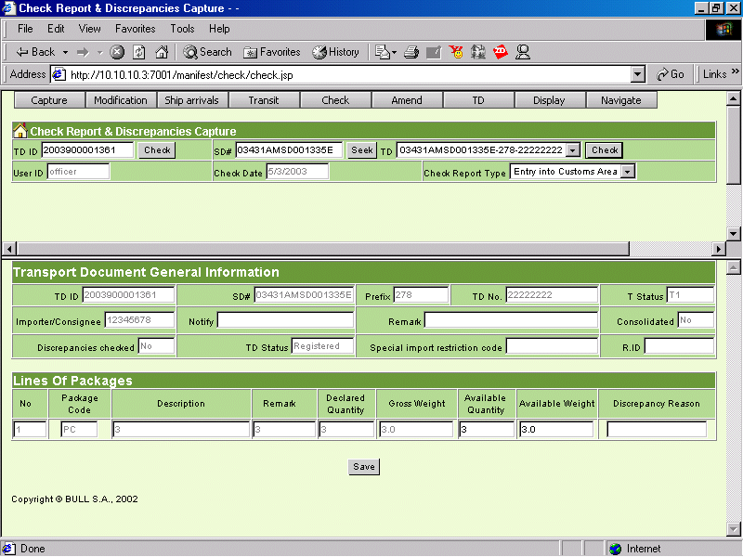
TDID
LineNo.
Available Quantity
Available Weight
Reason

End of Deconsolidation

DTD specification
<?xml version="1.0" encoding="UTF-8"?>
<!-- Copyright (c) 2002 Bull S.A. All rights reserved. -->
<!ELEMENT manifest (manisd+)>
<!ELEMENT manisd (tdid, lp+)>
<!ELEMENT tdid (#PCDATA)>
<!ELEMENT lp (lineno, avqty, avwei, reason?)>
<!ELEMENT lineno (#PCDATA)>
<!ELEMENT avqty (#PCDATA)>
<!ELEMENT avwei (#PCDATA)>
<!ELEMENT reason (#PCDATA)>

Description of the fields

Format
Field | Format | M/O | Occurs | Description
Transport documents
Tdid | N13 | M | Min:1/SD Max: No |  | N4: Fiscal year  N1: type  N8: Sequential number
Lines of packages
Line Number | N2 | M | Min: 1/TD Max: No |  | The Number for one line of package
Available quantity of packages | N8 | M |  |  | The available quantity set by Check Packages report
Available weight | N11,3 | M |  |  | The available weight set by Check Packages report
reason | an1000 | M/D |  |  | A reason is required when discrepancies exist between declare quantity and available quantity or between gross weight and available weight.

Correspondence with Check report screen (End of Deconsolidation)

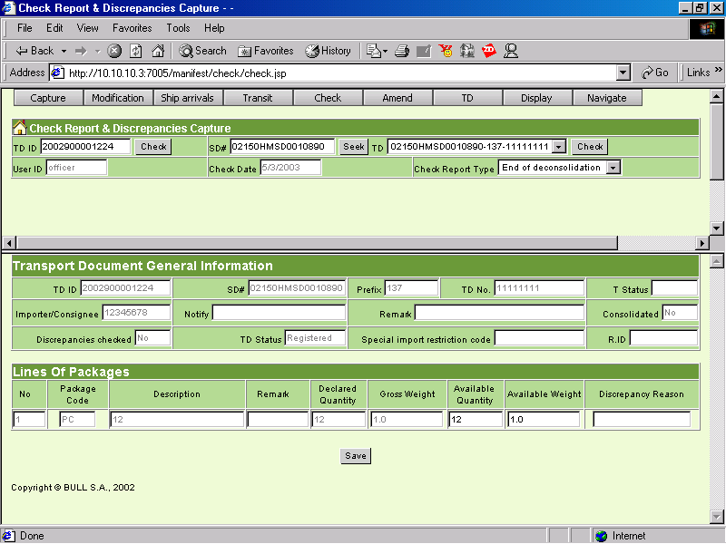
TDID
LineNo.
Available Quantity
Available Weight
Reason

Register a previously entered Cargo Manifest on import (SMSD)

DTD specification
<?xml version="1.0" encoding="UTF-8"?>
<!-- Copyright (c) 2002 Bull S.A. All rights reserved. -->
<!ELEMENT manifest (manisd+)>
<!ELEMENT manisd (sdno)>
<!ELEMENT sdno (#PCDATA)>

Description of the fields

Format
Field | Format | M/O | Occurs | Description
SD registration number | AN16 | M | Min: 1  Max: No |  | The Cargo SD registration number which will be registered

Correspondence with create/modify cargo manifest screen
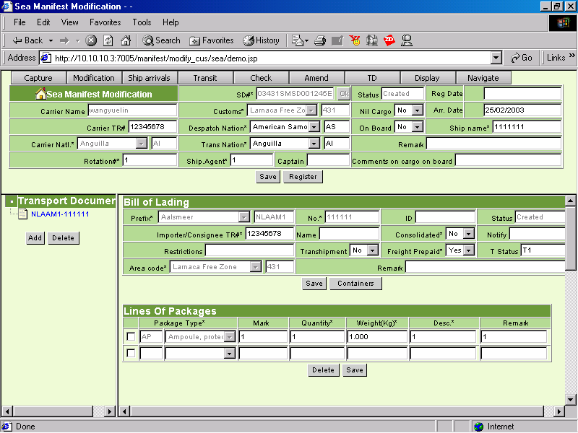
SD regNo.

Register a previously entered Deconsolidation Manifest on import (HMSD)

DTD specification
<?xml version="1.0" encoding="UTF-8"?>
<!-- Copyright (c) 2002 Bull S.A. All rights reserved. -->
<!ELEMENT manifest (manisd+)>
<!ELEMENT manisd (sdno)>
<!ELEMENT sdno (#PCDATA)>

Description of the fields

Format

Field | Format | M/O | Occurs | Description
SD registration number | AN16 | M | Min: 1  Max: No |  | The House SD registration number which will be registered

Correspondence with Create/Modify House Manifest Screen

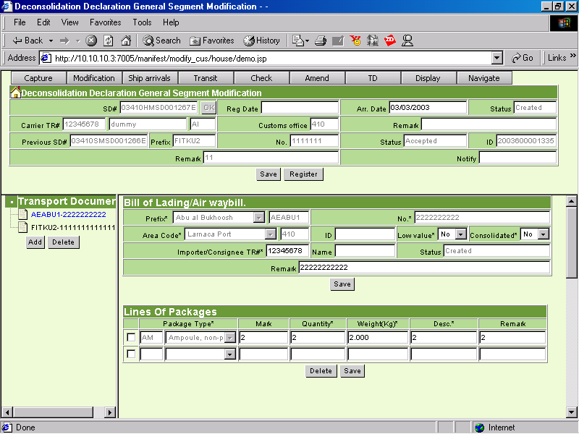
SD regNo.

